**PROJECT REPORT**

**On**

**SHAPE CLASSIFICATION SYSTEM**

Submitted to Rajasthan Technical University

in partial fulfillment of the requirement for the award of the degree of

**B.TECH.**

**in**

**COMPUTER ENGINEERING**

**Submitted By**

**GARVIT GOYAL (PIET15CE033)**

**ADITIYA DADHEECH (PIET15CE007)**

**JAIVEER SINGH (PIET15CE045)**

**Under the Guidance of**

**Mrs. Shruti Bijawat**

at



**POORNIMA INSTITUTE OF ENGINEERING & TECHNOLOGY, JAIPUR**

**Rajasthan Technical University, KOTA**

**OCTOBER, 2018**

**CERTIFICATE**

This is to be certified that the project entitled “ SHAPE CLASSIFICATION SYSTEM ” has been submitted for the Bachelor of Computer Science and Engineering, Poornima Institute Of Engineering & Technology, Jaipur during the academic year 2018-2019 is a bonafide piece of project work carried out by “ **Aditiya Dadheech, Garvit Goyal & Jaiveer Singh**” towards the partial fulfillment for the award of the Degree (B.Tech.) under the guidance of “**Mrs. Shruti Bijawat**” and supervision and no part of thereof has been submitted by them for any degree or diploma.

Project Guide Project Coordinator Mr. Deepak Moud

Mrs. Shruti Bijawat Prof. (Dr.) Praveen Gupta (H.O.D. CSE)

(Assistant Professor) (Professor)

**CANDIDATE’S DECLARATION**

We, Garvit Goyal (PIET15CE033**), Aditiya Dadheech (PIET15CE007) & Jaiveer Singh (PIET15CE045)** B.Tech (Semester- VIII) of “**Poornima Institute Of Engineering & Technology, Jaipur”**

hereby declare that the Project Report entitled **“ Shape Classification System ”** is an original work and data provided in the study is authentic to the best of our knowledge.This report has not been submitted to any other Institute for the award of any other degree.

|  |  |  |
| --- | --- | --- |
| **Garvit Goyal** | **aditiya dadheech** | **Jaiveer Singh** |
| **(piet15ce033)** | **(piet15ce007)** | **(PIET15ce045)** |

|  |  |
| --- | --- |
| **Place: PIET, Jaipur** |  |
| **Date: 23/10/2018** |  |

**ACKNOWLEDGEMENT**

It is our pleasure to be indebted to various people, who directly or indirectly contributed in the development of this work and who influenced our thinking, behavior and acts during the course of study.

We express our sincere gratitude to ***Dr. O. P. Sharma,*** Director, PIET for providing us an opportunity to undergo this Major Project as the part of the curriculum.

We are thankful to ***Mr. Deepak Moud, HOD, CS*** for his support, cooperation, and motivation provided to us during the training for constant inspiration, presence and blessings.

We are thankful to ***Mrs. Shruti Bijawat*** for his support, cooperation, and motivation provided to us during the training for constant inspiration, presence and blessings.

We also extend our sincere appreciation to***Prof. (Dr.) Praveen Gupta*** who provided his valuable suggestions and precious time in accomplishing our Project report.

Lastly, we would like to thank the almighty and our parents for their moral support and friends with whom we shared our day-to-day experience and received lots of suggestions that improved our quality of work.

|  |  |  |
| --- | --- | --- |
| **Garvit Goyal** | **aditiya dadheech** | **Jaiveer Singh** |
| **(piet15ce033)** | **(piet15ce007)** | **(PIET15ce045)** |

**TABLE OF CONTENTS**

|  |  |  |
| --- | --- | --- |
| **CHAPTER NO.** | **TOPICS** | **PAGE NO.** |
|  | TITLE PAGE | I |
|  | CERTIFICATE | II |
|  | CANDIDATE’S DECLARATION | III |
|  | ACKNOWLEDGEMENT | IV |
|  | TABLE OF CONTENTS | V |
|  | TABLE OF FIGURE | VI |
|  | ABSTRACT | VII |
| 1 | **INTRODUCTION TO PROJECT** | 1 |
|  |  |  |
|  | Project Aim and Objective  Problem Statement  Background of the Project (Literature Survey)  Software Requirements  Hardware Requirements |  |
| 2 | **PRODUCT BACKLOG** |  |
|  | 1. PRODUCT Backlog 2. Sprint Backlog-1 3. Sprint Backlog-2 4. Sprint Backlog-3 5. Sprint Backlog-4 |  |
|  |  |  |
| 3 | **TECHNOLOGY APPLIED AND PROJECT MANAGEMENT** |  |
|  | Brief Description of All technology Apply in the Project.  Project management  Agile  Relevance to Society  Ethics  Life Long Learning  Project Finance  Environment and Sustainability |  |
|  |  |  |
|  |  |  |
| 4 | **PROJECT IMPLEMENTATION** |  |
|  | Sprint Backlog-1  Sprint Backlog-2  Sprint Backlog-3  Sprint Backlog-4 |  |
|  |  |  |
| 5 | **CONCLUSION** |  |
|  | Results  Conclusion  Future Scope |  |
| 6 | ANNEXURES |  |
|  | References |  |
|  | APPENDIX/ANNEXURES |  |
|  | Research Paper ( if Presented and approved for publication) |  |
|  | CV |  |
|  |  |  |

**LIST OF FIGURES**

|  |  |  |
| --- | --- | --- |
| **S. NO.** | **FIGURE** | **PAGE NO.** |
| 1. |  | 13 |
| 2. |  |  |
| 3. |  |  |
| 4. |  |  |
| 5. |  |  |
| 6. |  |  |
| 7. |  |  |
| 8. |  |  |

**LIST OF TABLES**

**ABSTRACT**

Objects around us make our environment; in day to day life we tend to classify each of the

objects visible to us. We tend to classify each object like a ball is spherical; a notebook is

rectangular and so on using our senses. A machine like computer does not have senses to

recognize or even detect an object. We have to train or develop an algorithm for a machine

like computer to do so. The approach here is to classify some of the common objects around

us and decide whether they belong to any geometric shape or not. The shape of the objects

can be represented by some feature space which may be used for recognizing shape of the

objects. We use the corner detection method, signature method and chain code method to

achieve a good recognition. The corner detection method is based on detecting corners on the

boundary and then deriving the feature vector from the distance between the corners. The

signature method is based on the distance of the boundary points from the centre of the object

and all those distances from the feature vector. The chain code method is based on finding the

chain code of the object and then finds the histogram of it, which forms the feature vector.

The purpose of this thesis is to use all the three methods of recognition and visualize their

performances.

**KEYWORDS: Bounding Box, Extent, MATLAB, Rotation Compensation, Shape and Color recognition.**

**CHAPTER 1**

**INTRODUCTION TO PROJECT**

1. INTRODUCTION

1.1 What is object shape recognition?

In our everyday life we come across various objects of various shapes and with the help of

our senses we can easily classify and distinguish among them but for a computer, which does

not have any sense, we need to train or program it for such a classification or recognition of

different objects.

From our intuition we can easily say that the object in fig.1is a circle or a sphere. But what

about a computer, how will it recognize this object .We have to provide it with an artificial

intuition to do so. The following chapters provide us with one of the approaches to train a

machine like computer to recognize objects.

1.2 PRE-PROCEESSING

The image before it is actually processed needs pre-processing. The image taken from a

camera includes noise which introduces some distortions in the image which is needed to be

eliminated; so we use some filtering techniques like low-pass filtering for Gaussian noise,

median filtering for salt-pepper noise, notch filtering for periodic noise etc.

The next step is to convert the RGB image to gray scale image; after that the gray scale image

is converted to binary image by use of thresholding technique.

The process of filtering out the noise involves deriving the properties of the noise i.e. to

determine what kind of noise is present in the image. One way of determining the property of

noise is to take Fourier transform of the image and then study the spectra. Noises present in

the image in general have higher frequency than that of original image. There are different

types of noises that distort an image which classified according to their probability density

function. Although the salt and pepper noise is present almost in every image acquisition

systems.

The process of converting of gray scale to binary image is also important as it depends upon

the application i.e. which type of image is being converted to binary; whether it only a certain

amount of pixels which are higher gray level to be segmented or a significant amount of

pixels which are high gray levels but with variable intensity in different areas of the image.

For the first case we can use global thresholding and for the second we can use adaptive

thresholding by processing blocks by blocks in the thresholding operation in the image.

1.3 OBJECT BOUNDARY EXTRACTION

Object boundary detection lies in a very trivial concept that at the boundary of an object there

is a sudden abrupt change in the intensity value as we just cross the boundary.

We make use of this elegant concept. What we do is take any pixel and traverse to its

corresponding neighbor pixel and see the change in the intensity values during such travel. If

the change in intensity is too high, we assign the pixels from which we traverse as the

boundary pixels. We can use the derivative function for getting such a result. If the derivative

at a point is too high we can assign it as a boundary pixel.

The boundary of an object serves in our purpose to be a major and vital factor for recognition

and hence it’s efficient and precise detection is highly a necessity. Hereafter the boundary has

been detected, now we again apply some morphological operations to make the boundary

pixels to be of unit width to avoid any further complications in the processing of these

boundary elements.

1.4 MORPHOLOGICAL OPERATIONS

Our objective here is to recognize the shape of the object and hence we are least bothered of

the region inside the boundary of the object or outside it. Or it may happen that two or more

objects may be present touching each other’s boundaries. In those cases we use some

morphological operations to separate the objects boundaries or may be filling the holes or any

other discontinuities within the region enclosed by the boundaries or outside it to enhance our

boundary detection capabilities.

These morphological operations basically used are

1.Dilation

Dilation is generally used for thickening of the object.

2.Erosion

Erosion is generally used for thinning of the object.

3.Opening

Opening is generally used for smoothening the contour of an object or elimination of thin

protrusions.

4.Closing

Closing is generally used for filling gaps between close objects.

5.Hit or Miss Transform

Hit or Miss Transform is generally used for detecting particular pattern in the image.

1.5 CORNER DETECTION

1.5.1 HISTORY OF CORNER DETECTION:

The concept of corner detection was first proposed by Moravec [1980]. It actually considers a

local window which computes average intensity and the corner is detected if the change in

average intensity in every direction high; if the change in average intensity in only one

direction is high then it is an edge or if the change in average intensity in any direction is

small then the area there is flat.

The average change in intensity proposed E(x, y) is given by

Where Fx is the derivative along X-direction and Fy is the derivative along Y-direction and

W is averaging window of size s x t.

1.5.2 DETERMINANT METHOD FOR CORNER DETECTION:

Having detected the boundary of an object, the next step that we adopt here is to detect the

corners (if any) present in the boundary. The heart of this project lies in the efficient detection

of the corners of an object.

Corners may be described as those points in a boundary where the curvature of the boundary

is very high. Various elegant techniques are available for a corner detection like ‘Harris

Stephens corner detection technique’, but we here use a different technique to detect the

corners.

The corner detection we use is based on basic geometry of a 2D-plane. The process is as

follows ,consider three points placed at equal distance from each other on a plane. Let us

consider here a figure for a better understanding.

In the above figure the slope of the line p1p2(the line joining the points p1 and p2)is given by

the following expression:

tan(Ѳ1)=(y2-y1)/(x2-x1).

Similarly the slope of the second line p2p3(the line joining the points p2 and p3)is given by

the following expression:

tan(Ѳ2)=(y3-y2)/(x3-x2).

Where Ѳ1 and Ѳ2 are the angles of the lines p1p2 and p2p3 respectively with respect to the

x-axis.

Now suppose that the two lines are collinear then the slopes are equal and the condition can

be extended as determinant of [x2-x1 y2-y1;x3-x2 y3-y2] should be equal to zero.

And if they are not collinear then determinant of [x2-x1 y2-y1;x3-x2 y3-y2] is a non zero

value. So the point x2 is a corner point in case of a regular image like a square or a rectangle

etc.

We will use this concept to determine corners for an object given in an image. Let us define a

function that is the square of the determinant that is to be calculated in the above mentioned

method. We will take boundary points or pixels 3 at a time and then compute the determinant

as described below. We will not use the consecutive points but use a specified separation

between the points and move across every point on the boundary. This separation is the

specified connected distance between pixels in the boundary. We then assign a point to be a

corner if the function as described above for a set of three points is a non-zero value and

above certain threshold to detect all possible corner points.

Note : Here prior to the corner detection down sampling of the image can serve to be a boon

to the detection process, as it would remove any kind of discontinuities or distortions in the

boundary of the image. Down sampling is a technique to reduce the size of an image. It is

achieved in a simple yet powerful method by rejecting alternate rows and columns of an

image if the down sampling is done by an integer factor. Down sampling should be such that

it does not tend to reduce any considerable amount of information in the image but remove

unwanted discontinuities. Down sampling can also be very useful to normalize an image or

say an object as we will see in case of object recognition by chain code approach. Since,

without down sampling the chain code will differ for objects of same shape but different size.

Thus, down sampling should be used to obtain scaling invariance.

1.5.2 FEATURE EXTRACTION:

A simple question is how to make use of these detected corners for object shape recognition.

Various approaches can be made for such a task to perform.

Here we use a simple technique.

Deriving a feature vector from the corner points for recognition of a proper shape or an

approximation of an object to proper shape.

Suppose we have ‘n’ corners detected, then we form a feature vector of nC2 dimension. The

elements of this vector are the all possible distances between any two corner points. Then

what we sort this feature vector elements in decreasing order. Now the first element is the

length between corners which are the most farthest from each other and the last element is the

distance between the corners which are nearest to each other.

Now the challenge is to use the feature vector for a powerful recognition technique.

The first approach is to match the feature vector obtained from the above said algorithm of

the test image with the feature vector of the reference image stored in database.

The second approach we follow is a non-matching technique which is helpful in recognition

of proper shapes as described earlier or in a proper shape approximation to an object.

We will use some of the examples to have an insight on the use of feature vector.

Suppose the number of corners detected is 4. Now the feature vector would contain 6

elements. Now if all the elements are unequal with some error value permitted, then the

object is a quadrilateral. (The assumption here is that the object is a convex polygon). Again

if the first two elements are equal i.e. the diagonals are equal and all other elements are equal

then it is a square, of course some percentage of error permitted. Similarly if first two

elements are equal and fourth and fifth elements are unequal then it is a rectangle and lastly if

first two elements are not equal but all others are equal then it is a rhombus. The use is

completely based on the geometrical intuitive of any convex polygon.

Since, the feature vector consists only the Euclidean distance between any two corner points

of the object; thus the feature doesn’t get affected on rotation and translation; however it does

while scaling. To make it rotationally invariant the feature vector is normalized.

Note: A practical problem arises for a circle by corner detection method. By the theory we

have presented the number of corners detected in a circle should be ideally zero. But that is

not the case; we get a large number of corners for a circle. The reason is quite obvious; we

take the determinant method for corner detection. Since none of the set of three points given a

separation on the boundary of a circle is collinear, hence the determinant is non zero for a

great number of points. So we will apply other techniques like signature and chain code

method specifically for ellipse or a circle.

1.6 SIGNATURE

Signature of an object can be described to be a one dimensional mapping of a 2-D object. It is

actually the distance profile or the loci of the distance of any point on the boundary of the

object to the centre of the object.

Considering this definition of signature, the signature of a perfect circle should be a

horizontal straight line or variance of the signature being zero and the mean of the signature

is the radius of the circle. However if some error value is allowed then we check for the

variance of the signature to be less than a small value and if the condition is satisfied then the

object is classified as a circle.

We first find the boundary of the object. Then to make the no of points taken to be

standardized for every object we take 360 points each 1 degree apart from each other. Then

the distance of ea point from the centre is calculated and plotted. To make it rotationally

invariant what we do is the largest value of the signature i.e. the farthest point from the centre

in the sequence of signature values is made the starting point without affecting the sequence.

Then to make it scaling invariant we normalize the values of signature.

We can use this for recognition of objects either by matching with the signature of reference

objects stored in database or by using the properties of signature for simple objects.

1.7 FREEMAN CHAIN CODE

The chain code of an image is usually calculated from the boundary by sub sampling the

boundary and then assigning a specific number i.e.(0-3)for 4 connectivity and (0-7)for 8

connectivity as we travel from one point to the other on the boundary.

Thus chain code is nothing but the direction of traversal from one point to the other, each

direction being specified by a number.

1.7.1 USING CHAIN CODES FOR SHAPE RECOGNITION:

Various techniques are there for such an application like shape number which is a translation,

scaling and rotational invariant descriptor (invariance only for multiples of 90 degree

rotations.)

But here we use chain code histogram for recognition of shapes.

Pk = Lk / N

Where k = 0, 1, …, 7 ; Lk is the no. of kth code and N is the order of the chain code.

a) Representation of directions for 8-connectivity

b) Image

c) Freeman chain code of the boundary

d) Chain code histogram

In this method, we try to match the histogram of the FCC of the test image with the histogram

of the FCC of the stored image in database. This method is scaling and translation invariant;

however it is not rotational invariant.

**CHAPTER 2**

**PRODUCT BACKLOG**

(20 to 30 page)

1. **PRODUCT Backlog**

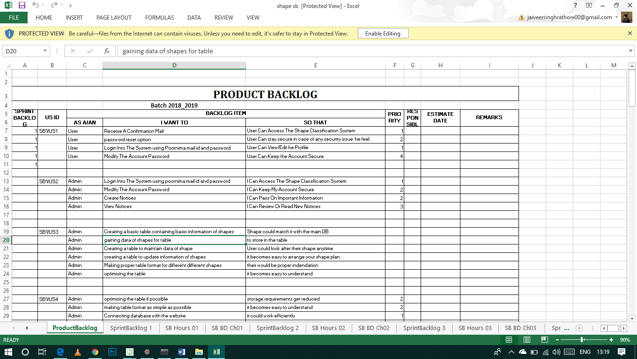

1. **Sprint Backlog-1**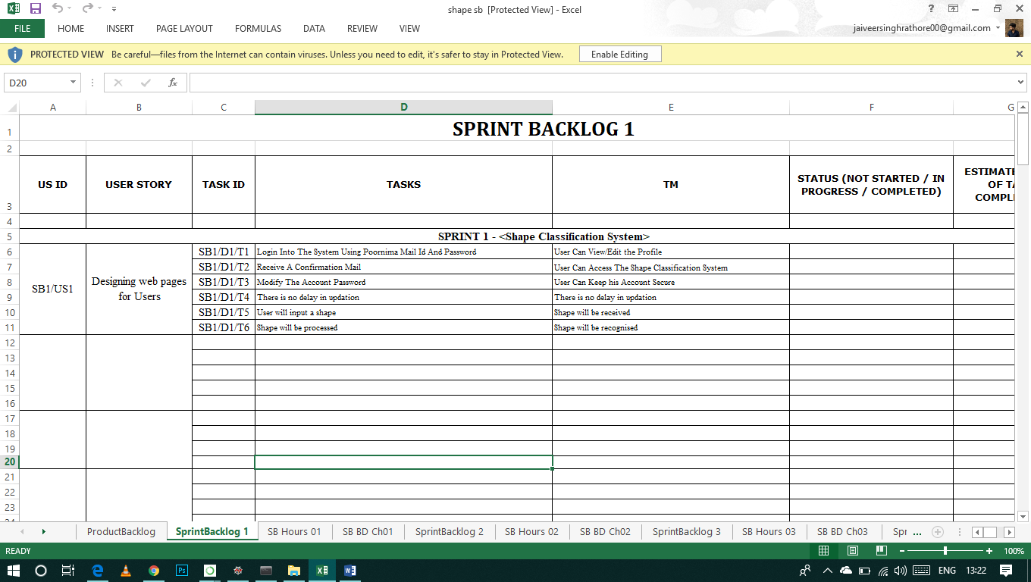

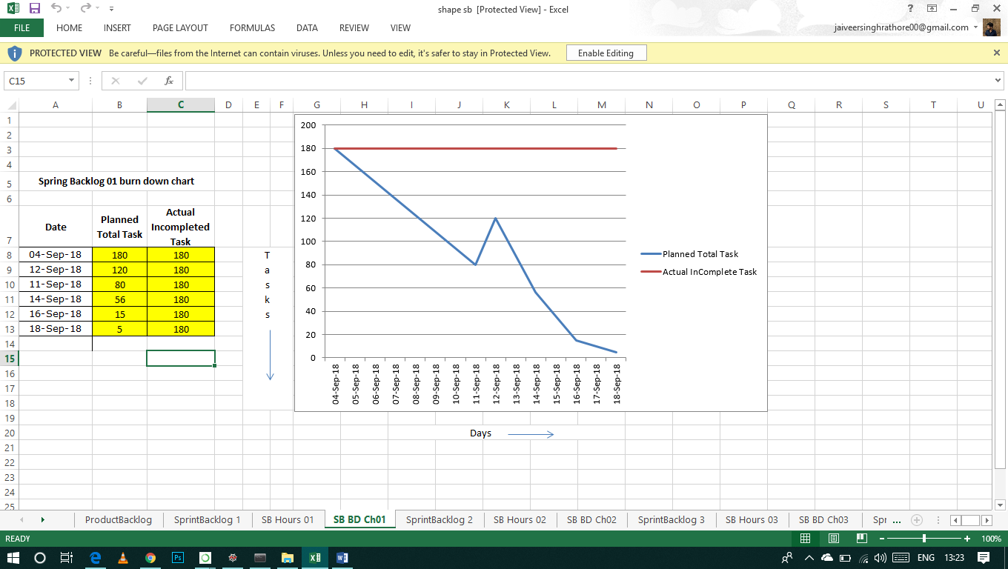

1. **Sprint Backlog-2**

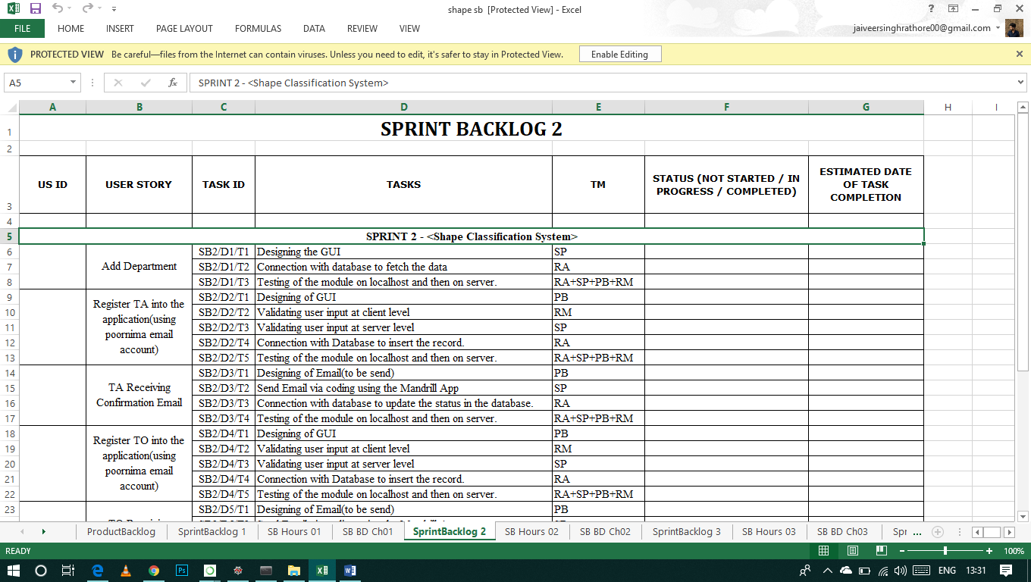

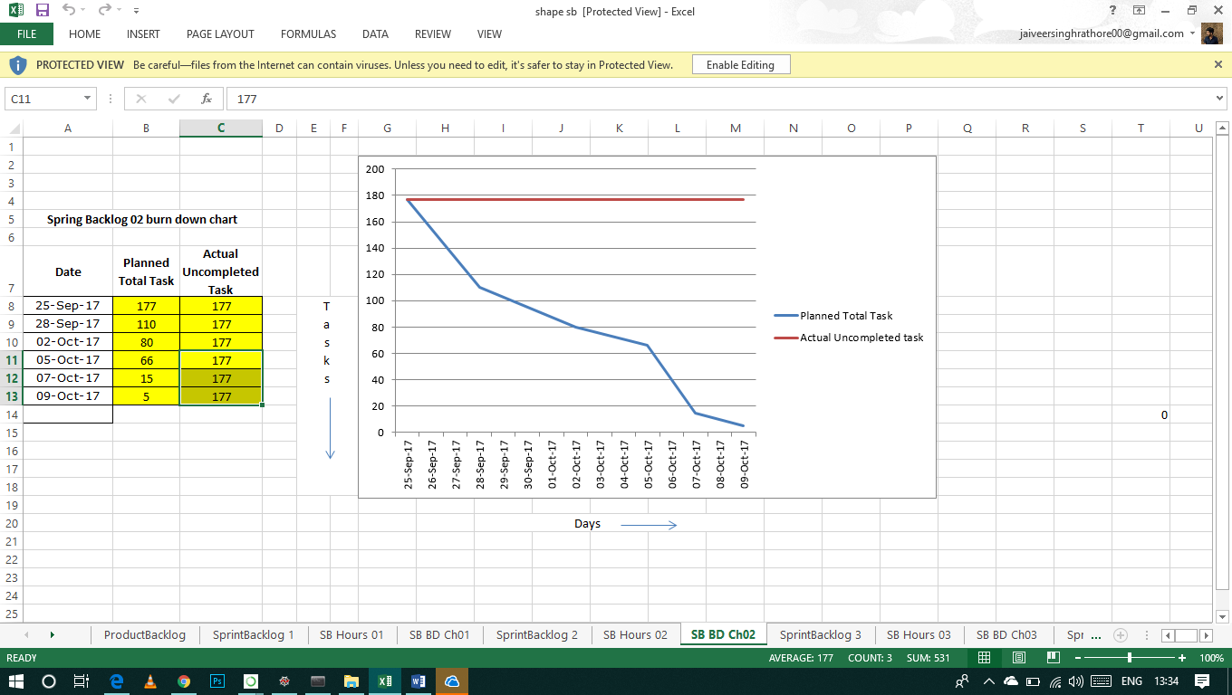

**4.Sprint Backlog-3**

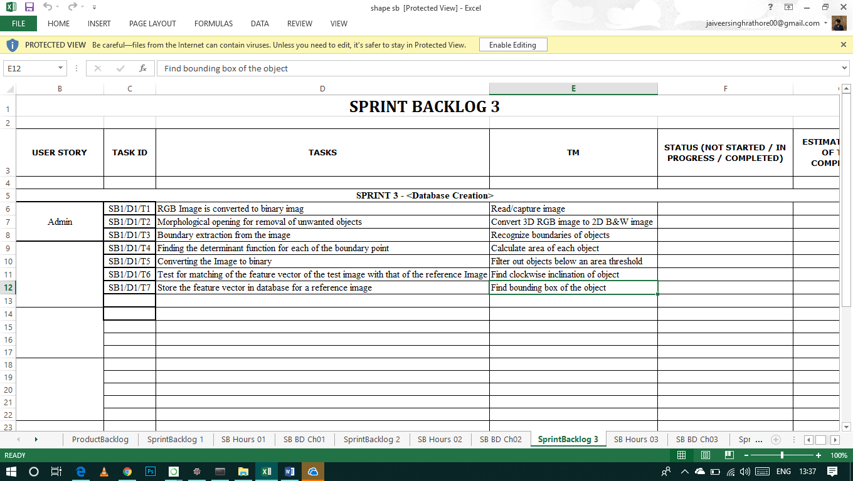

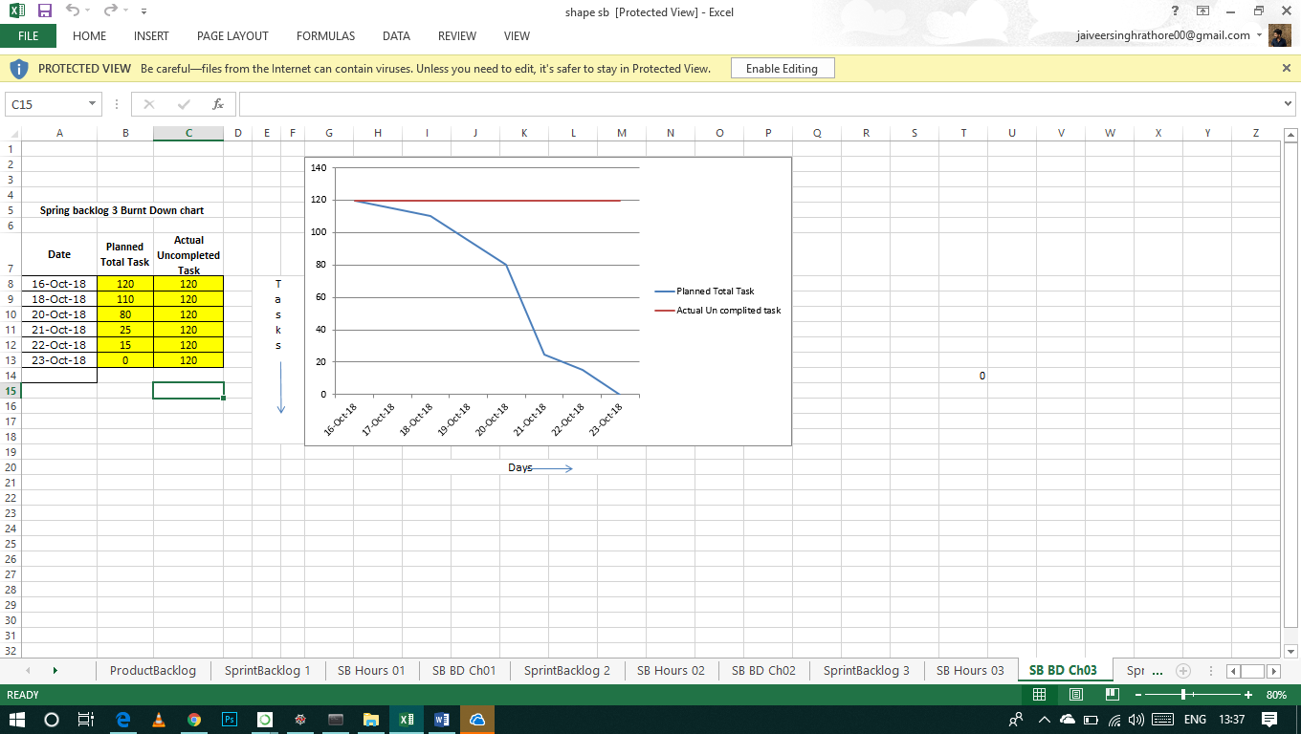

**5.Sprint Backlog-4**

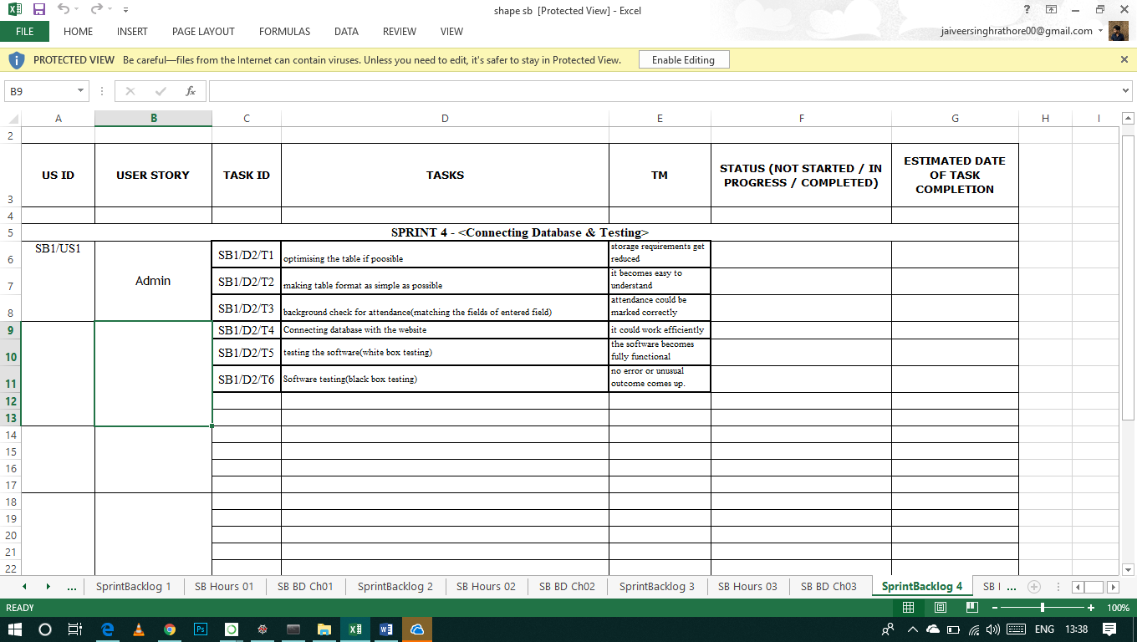

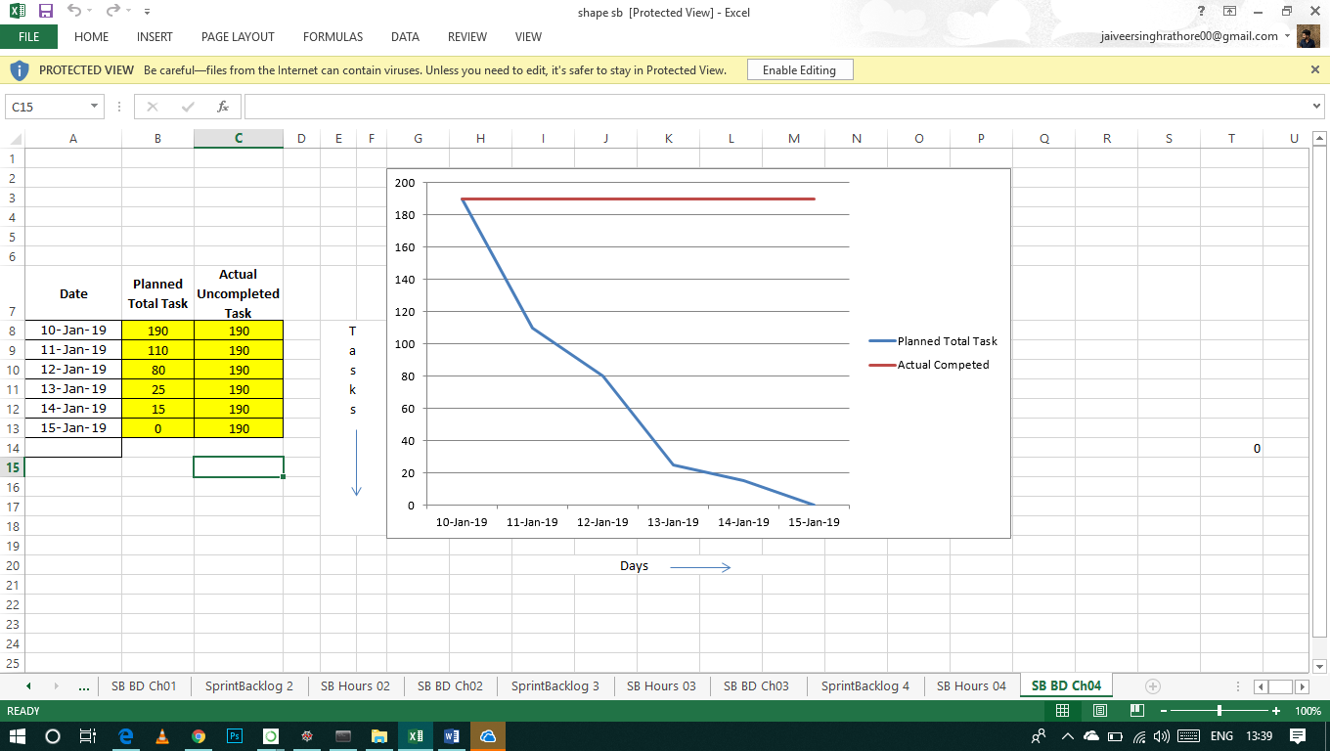

1. **Sprint Backlog-3**
2. **Sprint Backlog-4**

(Half page Introduction of Sprint Backlog -4 and then Print of Your Existing excel sheet , including All graphs)

**CHAPTER 3**

**TECHNOLOGY APPLIED AND PROJECT MANAGEMENT**

( 10 to 15 page)

Brief Description of All technologiesAppled in the Project.

**Project management :**

Project management is the application of processes, methods, knowledge, skills and experience to achieve the project objectives. General. A project is a unique, transient endeavor, undertaken to achieve planned objectives, which could be defined in terms of outputs, outcomes or benefits.

Project management is the practise of initiating, planning, executing, controlling, and closing the [work](https://en.wikipedia.org/wiki/Work_(project_management)) of a [team](https://en.wikipedia.org/wiki/Project_team) to achieve specific goals and meet specific success criteria at the specified time. A [project](https://en.wikipedia.org/wiki/Project) is a temporary endeavor designed to produce a unique product, service or result with a defined beginning and end undertaken to meet unique goals and objectives, typically to bring about beneficial change or added value. The temporary nature of projects stands in contrast with [business as usual](https://en.wikipedia.org/wiki/Business_operations), which are repetitive, permanent, or semi-permanent functional activities to produce products or services. In practice, the [management](https://en.wikipedia.org/wiki/Management) of such distinct production approaches requires the development of distinct technical skills and management strategies.

**Software project management**

Software project management is the art and science of planning and leading software projects. It is a sub-discipline of [project management](https://en.wikipedia.org/wiki/Project_management) in which [software](https://en.wikipedia.org/wiki/Software) projects are planned, implemented, monitored and controlled.

The job pattern of an IT company engaged in software development can be seen split in two parts:

* Software Creation
* Software Project Management

A project is well-defined task, which is a collection of several operations done in order to achieve a goal (for example, software development and delivery). A Project can be characterized as:

* Every project may have a unique and distinct goal.
* Project is not routine activity or day-to-day operations.
* Project comes with a start time and end time.
* Project ends when its goal is achieved hence it is a temporary phase in the lifetime of an organization.
* Project needs adequate resources in terms of time, manpower, finance, material and knowledge-bank.

**Software Project**

A Software Project is the complete procedure of software development from requirement gathering to testing and maintenance, carried out according to the execution methodologies, in a specified period of time to achieve intended software product.

**Need of software project management**

Software is said to be an intangible product. Software development is a kind of all new stream in world business and there’s very little experience in building software products. Most software products are tailor made to fit client’s requirements. The most important is that the underlying technology changes and advances so frequently and rapidly that experience of one product may not be applied to the other one. All such business and environmental constraints bring risk in software development hence it is essential to manage software projects efficiently.

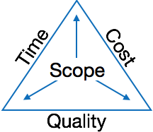

The image above shows triple constraints for software projects. It is an essential part of software organization to deliver quality product, keeping the cost within client’s budget constrain and deliver the project as per scheduled. There are several factors, both internal and external, which may impact this triple constrain triangle. Any of three factor can severely impact the other two.

Therefore, software project management is essential to incorporate user requirements along with budget and time constraints.

**Software Project Manager**

A software project manager is a person who undertakes the responsibility of executing the software project. Software project manager is thoroughly aware of all the phases of SDLC that the software would go through. Project manager may never directly involve in producing the end product but he controls and manages the activities involved in production.

A project manager closely monitors the development process, prepares and executes various plans, arranges necessary and adequate resources, maintains communication among all team members in order to address issues of cost, budget, resources, time, quality and customer satisfaction.

Let us see few responsibilities that a project manager shoulders -

**Managing People**

* Act as project leader
* Liaison with stakeholders
* Managing human resources
* Setting up reporting hierarchy etc.

**Managing Project**

* Defining and setting up project scope
* Managing project management activities
* Monitoring progress and performance
* Risk analysis at every phase
* Take necessary step to avoid or come out of problems
* Act as project spokesperson

**Software Management Activities**

Software project management comprises of a number of activities, which contains planning of project, deciding scope of software product, estimation of cost in various terms, scheduling of tasks and events, and resource management. Project management activities may include:

* **Project Planning**
* **Scope Management**
* **Project Estimation**

**Project Planning**

Software project planning is task, which is performed before the production of software actually starts. It is there for the software production but involves no concrete activity that has any direction connection with software production; rather it is a set of multiple processes, which facilitates software production. Project planning may include the following:

**Scope Management**

It defines the scope of project; this includes all the activities, process need to be done in order to make a deliverable software product. Scope management is essential because it creates boundaries of the project by clearly defining what would be done in the project and what would not be done. This makes project to contain limited and quantifiable tasks, which can easily be documented and in turn avoids cost and time overrun.

During Project Scope management, it is necessary to -

* Define the scope
* Decide its verification and control
* Divide the project into various smaller parts for ease of management.
* Verify the scope
* Control the scope by incorporating changes to the scope

**Project Estimation**

For an effective management accurate estimation of various measures is a must. With correct estimation managers can manage and control the project more efficiently and effectively.

Project estimation may involve the following:

* **Software size estimation**

Software size may be estimated either in terms of KLOC (Kilo Line of Code) or by calculating number of function points in the software. Lines of code depend upon coding practices and Function points vary according to the user or software requirement.

* **Effort estimation**

The managers estimate efforts in terms of personnel requirement and man-hour required to produce the software. For effort estimation software size should be known. This can either be derived by managers’ experience, organization’s historical data or software size can be converted into efforts by using some standard formulae.

* **Time estimation**

Once size and efforts are estimated, the time required to produce the software can be estimated. An effort required is segregated into sub categories as per the requirement specifications and interdependency of various components of software. Software tasks are divided into smaller tasks, activities or events by Work Breakthrough Structure (WBS). The tasks are scheduled on day-to-day basis or in calendar months.

The sum of time required to complete all tasks in hours or days is the total time invested to complete the project.

* **Cost estimation**

This might be considered as the most difficult of all because it depends on more elements than any of the previous ones. For estimating project cost, it is required to consider -

* + Size of software
  + Software quality
  + Hardware
  + Additional software or tools, licenses etc.
  + Skilled personnel with task-specific skills
  + Travel involved
  + Communication
  + Training and support

**Project Estimation Techniques**

We discussed various parameters involving project estimation such as size, effort, time and cost.Project manager can estimate the listed factors using two broadly recognized techniques

**Decomposition Technique**

This technique assumes the software as a product of various compositions.

There are two main models -

* **Line of Code** Estimation is done on behalf of number of line of codes in the software product.
* **Function Points** Estimation is done on behalf of number of function points in the software product.

**Empirical Estimation Technique**

This technique uses empirically derived formulae to make estimation.These formulae are based on LOC or FPs.

* **Putnam Model**

This model is made by Lawrence H. Putnam, which is based on Norden’s frequency distribution (Rayleigh curve). Putnam model maps time and efforts required with software size.

* **COCOMO**

COCOMO stands for COnstructiveCOstMOdel, developed by Barry W. Boehm. It divides the software product into three categories of software: organic, semi-detached and embedded.

**Project Scheduling**

Project Scheduling in a project refers to roadmap of all activities to be done with specified order and within time slot allotted to each activity. Project managers tend to define various tasks, and project milestones and they arrange them keeping various factors in mind. They look for tasks lie in critical path in the schedule, which are necessary to complete in specific manner and strictly within the time allocated. Arrangement of tasks which lies out of critical path are less likely to impact over all schedule of the project.

For scheduling a project, it is necessary to -

* Break down the project tasks into smaller, manageable form
* Find out various tasks and correlate them
* Estimate time frame required for each task
* Divide time into work-units
* Assign adequate number of work-units for each task
* Calculate total time required for the project from start to finish

**Resource management**

All elements used to develop a software product may be assumed as resource for that project. This may include human resource, productive tools and software libraries.

The resources are available in limited quantity and stay in the organization as a pool of assets. The shortage of resources hampers the development of project and it can lag behind the schedule. Allocating extra resources increases development cost in the end. It is therefore necessary to estimate and allocate adequate resources for the project.

Resource management includes -

* Defining proper organization project by creating a project team and allocating responsibilities to each team member
* Determining resources required at a particular stage and their availability
* Manage Resources by generating resource request when they are required and de-allocating them when they are no more needed.

**Project Risk Management**

Risk management involves all activities pertaining to identification, analysing and making provision for predictable and non-predictable risks in the project. Risk may include the following:

* Experienced staff leaving the project and new staff coming in.
* Change in organizational management.
* Requirement change or misinterpreting requirement.
* Under-estimation of required time and resources.
* Technological changes, environmental changes, business competition.

**Risk Management Process**

There are following activities involved in risk management process:

* **Identification -** Make note of all possible risks, which may occur in the project.
* **Categorize -** Categorize known risks into high, medium and low risk intensity as per their possible impact on the project.
* **Manage -** Analyze the probability of occurrence of risks at various phases. Make plan to avoid or face risks. Attempt to minimize their side-effects.
* **Monitor -** Closely monitor the potential risks and their early symptoms. Also monitor the effects of steps taken to mitigate or avoid them.

**Project Execution & Monitoring**

In this phase, the tasks described in project plans are executed according to their schedules.

Execution needs monitoring in order to check whether everything is going according to the plan. Monitoring is observing to check the probability of risk and taking measures to address the risk or report the status of various tasks.

These measures include -

* **Activity Monitoring -** All activities scheduled within some task can be monitored on day-to-day basis. When all activities in a task are completed, it is considered as complete.
* **Status Reports -** The reports contain status of activities and tasks completed within a given time frame, generally a week. Status can be marked as finished, pending or work-in-progress etc.
* **Milestones Checklist -** Every project is divided into multiple phases where major tasks are performed (milestones) based on the phases of SDLC. This milestone checklist is prepared once every few weeks and reports the status of milestones.

**Project Communication Management**

Effective communication plays vital role in the success of a project. It bridges gaps between client and the organization, among the team members as well as other stake holders in the project such as hardware suppliers.

Communication can be oral or written. Communication management process may have the following steps:

* **Planning** - This step includes the identifications of all the stakeholders in the project and the mode of communication among them. It also considers if any additional communication facilities are required.
* **Sharing** - After determining various aspects of planning, manager focuses on sharing correct information with the correct person on correct time. This keeps every one involved the project up to date with project progress and its status.
* **Feedback** - Project managers use various measures and feedback mechanism and create status and performance reports. This mechanism ensures that input from various stakeholders is coming to the project manager as their feedback.
* **Closure** - At the end of each major event, end of a phase of SDLC or end of the project itself, administrative closure is formally announced to update every stakeholder by sending email, by distributing a hardcopy of document or by other mean of effective communication.

After closure, the team moves to next phase or project.

**Configuration Management**

Configuration management is a process of tracking and controlling the changes in software in terms of the requirements, design, functions and development of the product.

IEEE defines it as “the process of identifying and defining the items in the system, controlling the change of these items throughout their life cycle, recording and reporting the status of items and change requests, and verifying the completeness and correctness of items”.

Generally, once the SRS is finalized there is less chance of requirement of changes from user. If they occur, the changes are addressed only with prior approval of higher management, as there is a possibility of cost and time overrun.

**Project management Tools:**

Project management required tools to manage the work , time and resources. At present many of the software are available for project management. Some of the popular software tools are as follows.

### 01. [Trello](http://send.getapp.com/aff_c?offer_id=677&aff_id=1371)

Trello is an project management tool, instead this app is a free visual way to to glance at the entire project with a single view. With Trello you can organise cards, these cards can be your thoughts, conversations and to-do lists and be placed on a board for everyone to collaborate on.

### 02. [Basecamp](http://send.getapp.com/aff_c?offer_id=637&aff_id=1371)

Basecamp is the granddaddy of project management apps. Basecamp is considered the leading project management tool around. It boost a simple and easy to use interface to collaborate with your team and client. It allows you to create multiple projects and setup discussions, write to-do lists, manage files, create and share documents, and organise dates for scheduling.

### 03. [Teamwork Projects](http://send.getapp.com/aff_c?offer_id=947&aff_id=1371)

Teamwork Projects is the ultimate productivity tool to manage projects with your team. Teamwork allows you to keep all your projects, tasks and files all in one place and easily collaborate with a team. Teamwork helps you to visualise the entire project through a marked calendar and gantt chart and setup reporting. Teamwork supports file management with Google Drive, Box.com and Dropbox. As well as integration with leading apps such as third party accounting software and customer support apps.

### 04. [Resource Guru](https://resourceguruapp.com/)

Billed as the "simple way to schedule people, equipment and other resources", Resource Guru is a streamlined resource scheduling and leave management tool that’s designed to keep your projects on track. You can plan your team's workloads, receive daily booking reminders, report on KPIs, and more. Apple, Saatchi & Saatchi and Deloitte are among some of the cloud-based team calendar’s heavyweight customers.

### 05. [ActiveCollab](http://send.getapp.com/aff_c?offer_id=949&aff_id=1371)

ActiveCollab recently released its new version 5.0. The new revamped app is now more powerful and focused project management tool. It offers team collaborating features, task management, time tracking and importing expenses. One of the biggest asset of ActiveCollab is it offers invoicing features. You are able to track payments and expenses and have invoices paid directly within ActiveCollab with PayPal, and other credit card payments.

### 06. [Zoho Projects](http://send.appdoubler.com/aff_c?offer_id=101&aff_id=1371)

Zoho offers a wide range of business software including Projects. Zoho Projects is an proficient tool to project plan and project coordinator from start to finish. It boost all the features you need for project management with some advance features including reporting, integration with Google Apps and Dropbox, bug tracking, setup Wiki Pages to build a repository of information, forums and more.

### 07. [Jira](http://send.getapp.com/aff_c?offer_id=281&aff_id=1371)

Jira is specifically targeted for software development teams. Jira offers abilities to raise issues and bugs. Jira makes it real easy to track bugs and see which issues are still outstanding and how much time was spent on each task. Jira offer other products including Confluence a document collaboration tool, and HipChat a team chat and video and file sharing platform and other products.

### 08. [Asana](http://send.getapp.com/aff_c?offer_id=587&aff_id=1371)

Asana is the easiest way for teams to track their work so everyone knows who's doing what, by when. With tasks, projects, conversations and dashboards, Asana keeps your work organized, and teammates accountable so you can move work forward faster. Asana also lets you keep track of your work wherever you are with mobile apps for both iOS and Android.

### 09. [Podio](http://send.getapp.com/aff_c?offer_id=951&aff_id=1371)

Podio is a ever growing tool to organise and communication tool for any business. Podio allows you to personalise this platform to fit your business needs. Besides being able to communicate with a team, setup task management, use as a file storage system, like a traditional project management app, Podio can be an internal intranet for all your colleagues and departments to interact.

### 10. [Freedcamp](https://freedcamp.com/)

Whatever your project may be, either setting up an event, a web project or organising a wedding, Freedcamp helps you organise and plan effectively. Freedcamp has an organised dashboard to view the entire project at a glance. You can easily setup tasks, use sticky notes to visually setup tasks and organise them into the calendar. Freedcamp provides advance add-ons for high level business use including CRM, invoicing, issue tracking and setting up wiki pages.

### 11. [Wrike](http://send.getapp.com/aff_c?offer_id=239&aff_id=1371)

Wrike is advance application to help you work smarter. By making sure you are always staying on track and ensure you have the adequate resources to finish on time and on budget.Setting up tasks, engage your team and integrate with your business tools including Google Apps, Microsoft Excel, Dropbox and many more is so easy with Wrike.

**PO and Their Relevance to project**

**PO1: Engineering knowledge:**Apply the knowledge of mathematics, science, engineering fundamentals and an engineering specialization to the solution of complex engineering problems.

In this project creation process engineering knowledge of the software engineering and Electronics engineering have been applied. we have used software engineering , HTML,xml, java , android , java script , php , j2ee, data base , oracle , my sql , mango and other programming language and database to the project. We have applied all above engineering subjects in our projects.

**PO2: Problem analysis:**Identify, formulate, review research literature, and analyze complex engineering problems reaching substantiated conclusions using first principles of mathematics, natural sciences, and engineering sciences.

In our projects we have identified an problem , once verified by the client we have worked to identify the solution using all of our theoretical and practical knowledge.

**PO3: Design/development of solutions:** Design solutions for complex engineering problems and design system components or processes that meet the specified needs with appropriate consideration for the public health and safety, and the cultural, societal, and environmental considerations.

**PO4: Conduct investigations of complex problems:** Use research-based knowledge and research methods including design of experiments, analysis and interpretation of data, and synthesis of the information to provide valid conclusions.

**PO5: Modern tool usage:**Create, select, and apply appropriate techniques, resources, and modern engineering and IT tools including prediction and modeling to complex engineering activities with an understanding of the limitations.

In the project development we have applied Integrated Development Environment IDE for the rapid development of the code, used web server for the software development.

**PO6: The engineer and society**: Apply reasoning informed by the contextual knowledge to assess societal, health, safety, legal and cultural issues and the consequent responsibilities relevant to the professional engineering practice.

In 1961 , the Conference of Engineering Societies of Western Europe and the United States of America defined "professional engineer" as follows.

A professional engineer is competent by virtue of his/her fundamental education and training to apply the scientific method and outlook to the analysis and solution of engineering problems. He/she is able to assume personal responsibility for the development and application of engineering science and knowledge, notably in research, design, construction, manufacturing, superintending, managing and in the education of the engineer. His/her work is predominantly intellectual and varied and not of a routine mental or physical character. It requires the exercise of original thought and judgement and the ability to supervise the technical and administrative work of others. His/her education will have been such as to make him/her capable of closely and continuously following progress in his/her branch of engineering science by consulting newly published works on a worldwide basis, assimilating such information and applying it independently. He/she is thus placed in a position to make contributions to the development of engineering science or its applications. His/her education and training will have been such that he/she will have acquired a broad and general appreciation of the engineering sciences as well as thorough insight into the special features of his/her own branch. In due time he/she will be able to give authoritative technical advice and to assume responsibility for the direction of important tasks in his/her branch.

**PO7: Environment and sustainability:** Understand the impact of the professional engineering solutions in and environmental contexts, and demonstrate the knowledge of, and need for sustainable development.

Sustainability is the ability to continue a defined behavior indefinitely. Sometimes environmental, social and economic are termed to be the three pillars of sustainability.

**PO8: Ethics**: Apply ethical principles and commit to professional ethics and responsibilities and norms of the engineering practice

The ethics of engineers and the fundamental principles for Engineers are as follows.

Engineers uphold and advance the integrity, honor and dignity of the engineering profession by:

I. using their knowledge and skill for the enhancement of human welfare;

II.being honest and impartial, and servicing with fidelity the public, their employers and clients;

III. Striving to increase the competence and prestige of the engineering profession; and

IV. Supporting the professional and technical societies of their disciplines.   
  
  
**PO9. Individual and team work**: Function effectively as an individual and as a member or leader in diverse teams, and in multidisciplinary settings.  
  
  
To work successful in team a team member must have following capabilities.

**1. The Ability to Listen**

it is important to listen to one another's ideas. Too often in a business setting, you have a group of people simply waiting for their turn to speak, not paying one iota of attention to the persons on their left or right. So it is a good teamwork skill to have the ability to listen

**2. Check Your Ego**

This isn't saying abandon your ego all together, because that isn't healthy. But leaving your ego at the door temporarily is a very important team work skill. The reason this is so essential is because there is always someone better than you at something, no matter how brilliant you are.

**3. Critique**

By critique, I mean constructive criticism. Be able to give others constructive criticism and be able to listen to others critique your ideas and work. There shouldn't be any offense taken to constructive criticism. You all want to succeed, and this is a vital step in doing so.

**4. Delegation**

The mentality must be applied to teamwork. Delegate roles to those who do them best.

**5. Show Respect**

If you and another person happen to be paired up and can't stand each other, you can still put that aside for a couple of hours, treat each other civilly, and complete the tasks at hand. You may even overcome the dislike toward one another.

**6. Be Helpful**

This is simple.If one of your teammates does not understand an idea, discussion, or task that is being completed, take the necessary time to explain it to them and work with them. There are no weak links when everyone helps one another. Some take longer to learn than others, but that doesn't mean that they are of less intelligence. If in a meeting someone asks a question because they don't understand, don't frown at them. Just answer the questions patiently and concisely.

**7. Question One Another**

If someone brings up a topic of discussion and a solution to this topic, question them. Respectfully question, don't badger. Rather, ask them how it will work, why it will work over the long-run, and how everyone else can implement the idea.

**8. Participation**

Have the entire team encourage shy people to engage in the topics of discussion. Don't demand it, but make them realize that you really want to hear their ideas.

**9. Rational Debate**

Bad ideas are bad for teams. Spirited, friendly, rational debate is where facts come forward, ideas are born, and quality rises to the top.

**10. Set The Right Environment**

Try to make the space in which your team is assembled as comfortable, relaxing, and inviting as possible. You do not want your team to be tense and with frayed nerves.

**PO 10: Communication:**Communicate effectively on complex engineering activities with the engineering community and with society at large, such as, being able to comprehend and write effective reports and design documentation, make effective presentations, and give and receive clear instructions.

**PO11: Project management and finance:**Demonstrate knowledge and understanding of the engineering management principles and apply these to one’s own work, as a member and leader in a team, to manage projects and in multidisciplinary environments.

Project management is the application of processes, methods, knowledge, skills and experience to achieve the project objectives. In general project is a unique, transient endeavour, undertaken to achieve planned objectives, which could be defined in terms of outputs, outcomes or benefits.

**PO12: Life-long learning**: Recognize the need for and have the preparation and ability to engage in independent and lifelong learning in the broadest context of technological change.

Life Long Learning means is the provision or use of both formal and informal learning opportunities throughout people's lives in order to foster the continuous development and improvement of the knowledge and skills needed for employment and personal fulfillment

**CHAPTER 4**

**PROJECT IMPLEMENTATION**

( Each Spring Backlog of 13-17 Pages total Chapter Size 50-70 pages)

1. Sprint Backlog-1  
     
   ( ***Project Design , Algo ,Database Design , ERD , Project Code ( Sample code only Limited to Max of 2-3 Page if needed , Project Screen Shots*** )
2. Sprint Backlog-2

( ***Project Design , Algo ,Database Design , ERD , Project Code ( Sample code only Limited to Max of 2-3 Page if needed , Project Screen Shots***

1. Sprint Backlog-3

( ***Project Design , Algo ,Database Design , ERD , Project Code ( Sample code only Limited to Max of 2-3 Page if needed , Project Screen Shots*** )

1. Sprint Backlog-4  
     
   ( ***Project Design , Algo ,Database Design , ERD , Project Code ( Sample code only Limited to Max of 2-3 Page if needed , Project Screen Shots*** )

**CHAPTER 5**

**CONCLUSION**

Results- Shapes have been classified(Triangle, Rectangle, Square, Circle, etc.)

Conclusion -

The algorithm discussed in this paper is a simple, yet effective method of analyzing the shapes and colors of objects. The concept of recognizing shapes on the basis of easily obtainable metrics has been extensively used by us in our research on recognition of breast cancer cells from a given tissue sample. In our research, the algorithm was used to recognize the shapes of all cells and the Extent parameter of normal healthy cells was noted. As cancer cells differ from healthy cells in terms of shape as well as color, their Extent values as well as RGB content do not match those of healthy cells and can therefore be easily identified and quantified. The applications are not restricted to the bio-medical field but can extend to any field that requires classification of different objects based on their physical appearance. This may include quality inspection in assembly lines, artificial robotic intelligence, computer vision, recognition of vehicles at toll booths or traffic signals for traffic status determination, etc.

Future Scope –

Research in biometrics identification using a fingerprint or a face image or a recorded voice and others. Using this features can be identify a person, first a feature set are extracted from the image or the audio, then are compare with an stored feature set, some algorithms and process are well known to made this task.

**ANNEXURES**

References

* Gonzalez and Woods.[2009]. Digital Image Processing, Pearson Publications.
* Gonzalez, Woods, and Eddins.[2010]. Digital Image Processing with Matlab, Tata McGraw Hill Publications.
* Sonka , Hlavac and Boyle.[1998]. Image Processing, Analysis and Machine Vision, CL-Engineering Publications.
* Jusoh, Nor Amizam and Zain , Jasni Mohamad.[2009]. “Application of Freeman Chain Codes: An Alternative Recognition Technique for Malaysian Car Plates,’’ IJCSNS International Journal of Computer Science and Network Security, VOL.9 No.11

**Instructions**

For Chapter Heading

Font: Times New Roman

Font Size: 14, Bold

Alignment: Center

Line Spacing 1.5

For Paragraph Heading

Font: Times New Roman

Font Size: 12, Bold

Alignment: Left

Line Spacing 1.5

For paragraph

Font: Times New Roman

Font Size: 12

Line Spacing 1.5

Alignment: Justify

Line Spacing 1.5